**Batch 2: Group 1**

**Assignment 9**

**Aim:** Installing Jenkins, Post-installation setup wizard, Unlocking Jenkins

**Objectives:**

1. Successfully install Jenkins on a server and configure it for use in continuous integration and continuous delivery (CI/CD) pipelines.
2. Complete the post-installation setup wizard to customize Jenkins settings according to project requirements and security considerations.
3. Unlock Jenkins to gain administrative access and begin configuring jobs, plugins, and pipelines for automated software builds and deployments.

**Theory:**

**Jenkins Installation:**

Jenkins is an open-source automation server used for building, testing, and deploying software. Installation typically involves downloading the Jenkins WAR file and deploying it in a servlet container such as Apache Tomcat. Once installed, Jenkins provides a web-based interface for managing automation tasks, configuring jobs, and monitoring build statuses.

**Post-installation Setup Wizard:**

After installation, Jenkins initiates a setup wizard to guide users through essential configuration steps. This includes setting up the initial admin user, installing suggested plugins, and configuring the Jenkins URL. Additionally, users can choose to customize security settings, such as enabling authentication and authorization mechanisms, to ensure secure access to Jenkins resources.

**Unlocking Jenkins:**

Upon completing the setup wizard, Jenkins is locked by default to prevent unauthorized access. To unlock Jenkins, users need to retrieve the initial administrative password from the server's file system and input it into the web interface. This step grants administrative privileges, allowing users to configure Jenkins, install additional plugins, and create jobs for automating software development processes.

**Implementation:**

1. Download Jenkins from jenkins.io

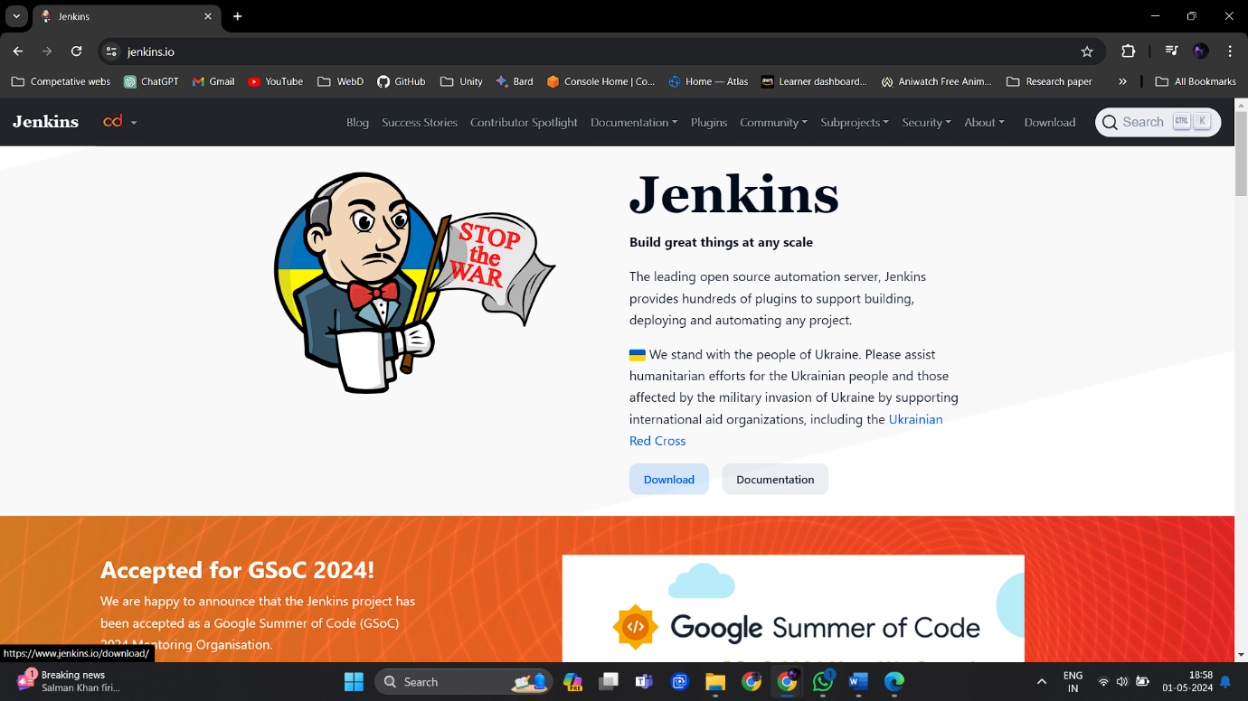

1. Select LTS windows version.

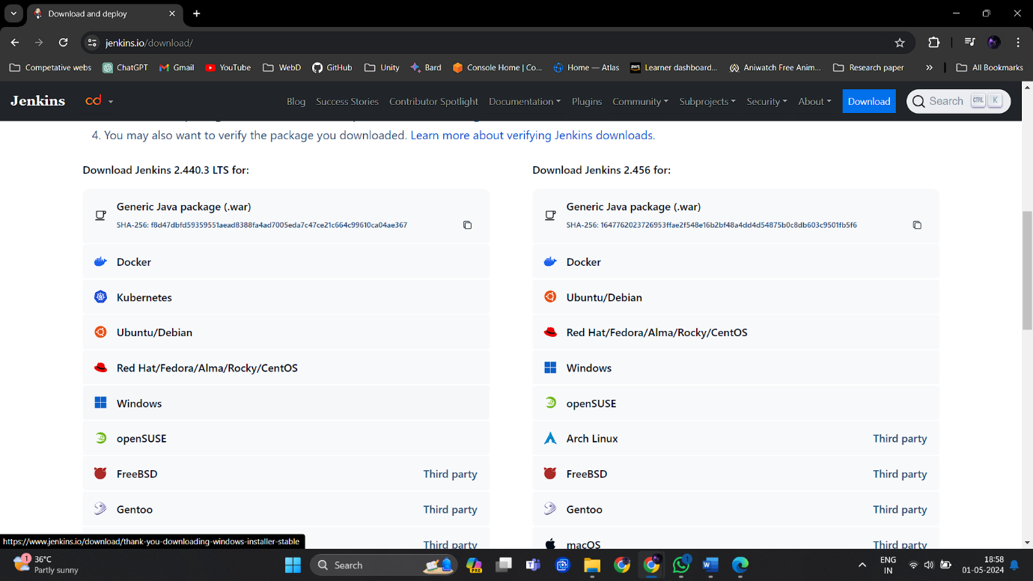

1. Once the msi file is downloaded open it.

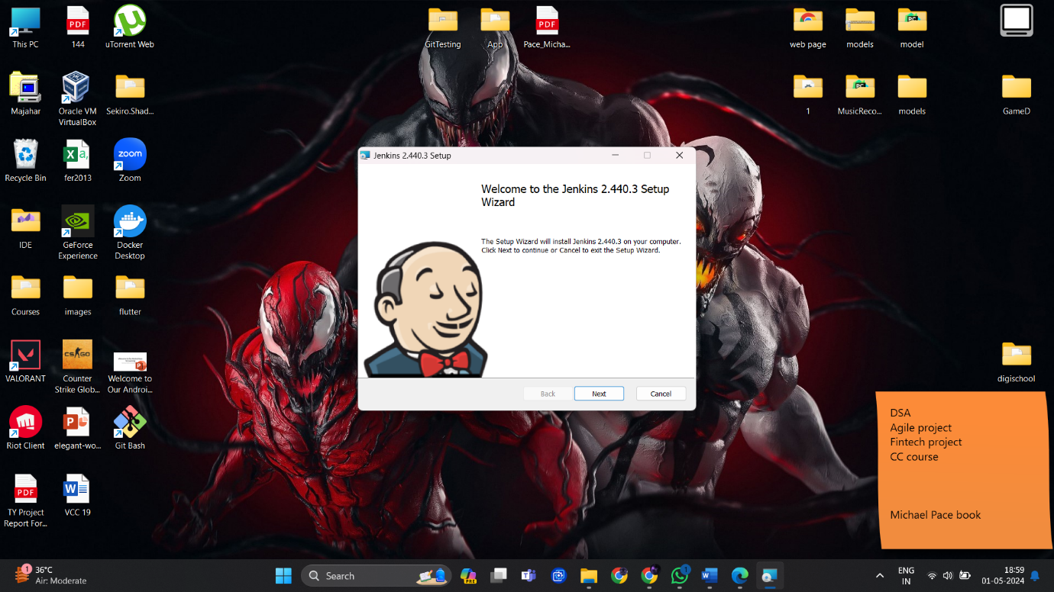

1. Select directory for Jenkins to be installed in.

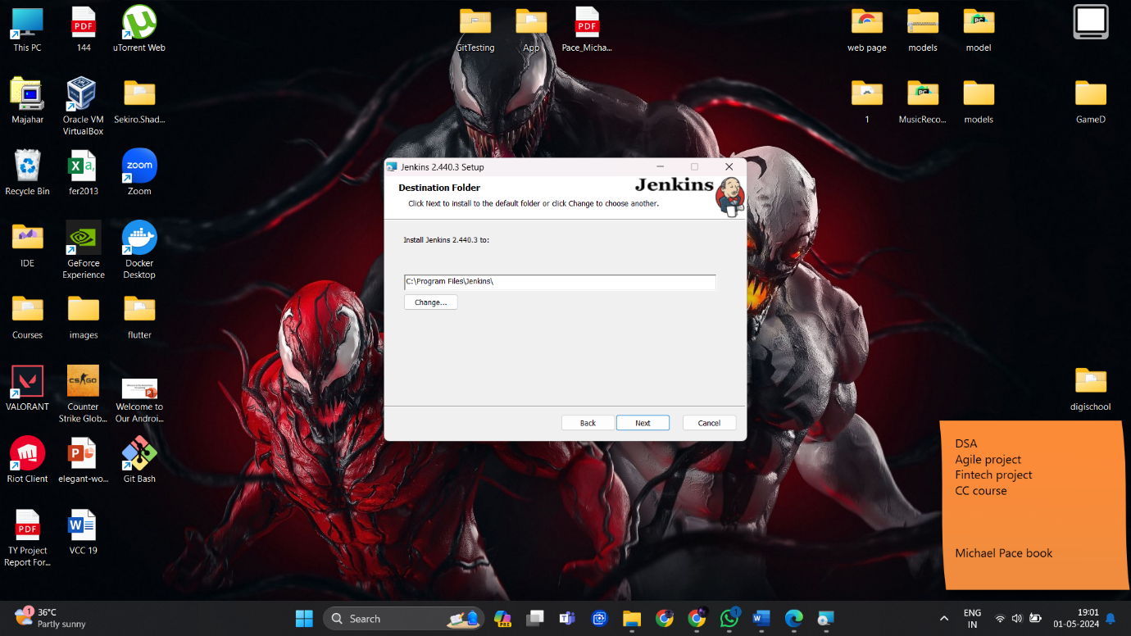

1. Choose the system as LocalSystem, for logging in manually with username and password.

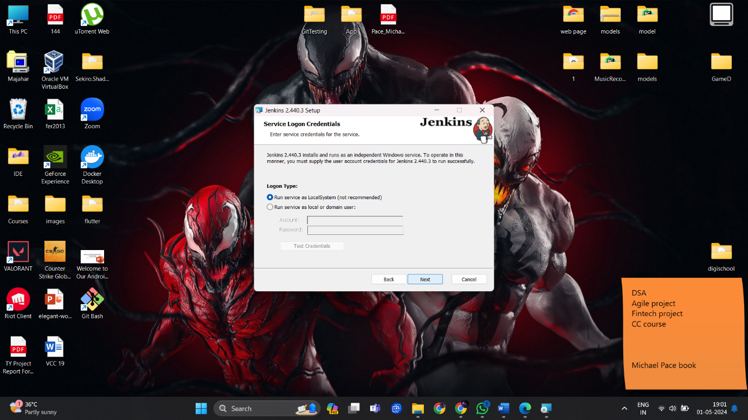

1. Check if the default port for Jenkins i.e. port 8080 is available.

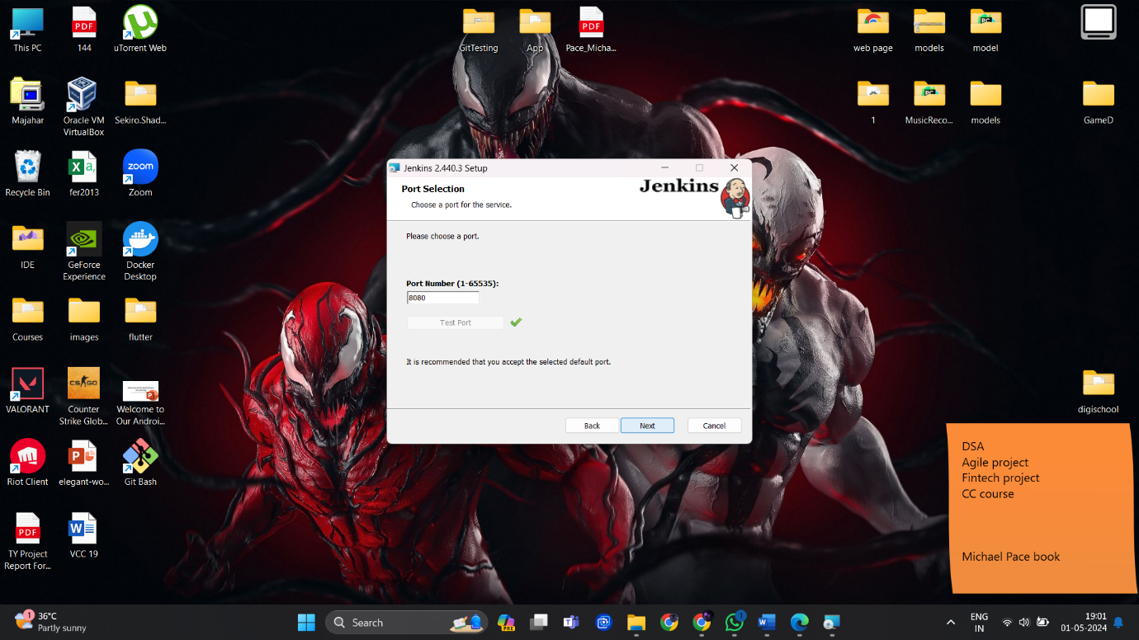

1. Select Java JDK path (Recommended for Jenkins are 11, 17, 21).

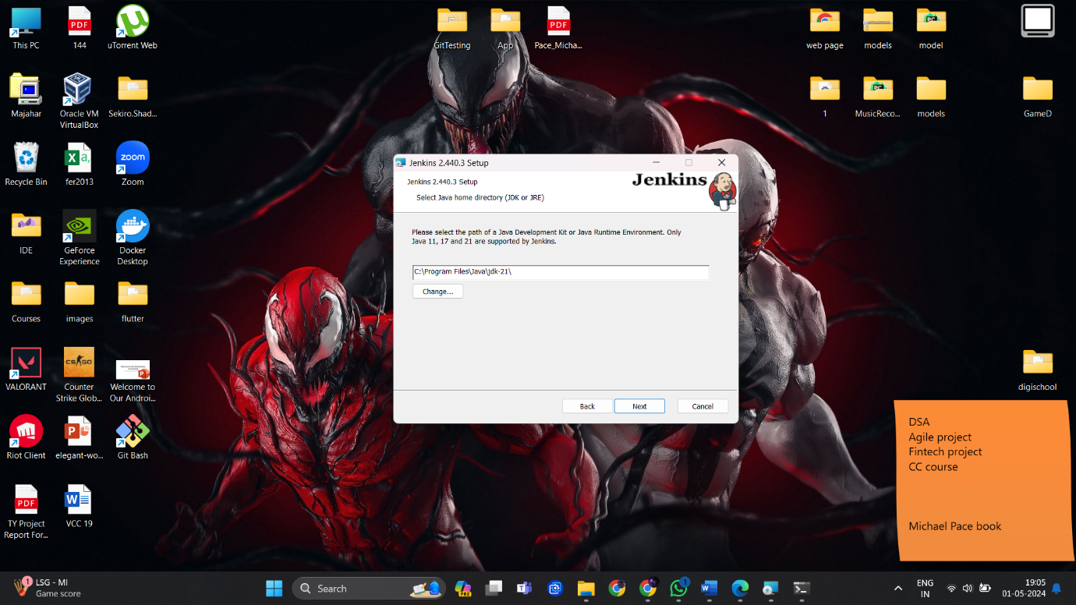

1. Continue with the default set up until Installation is completed.

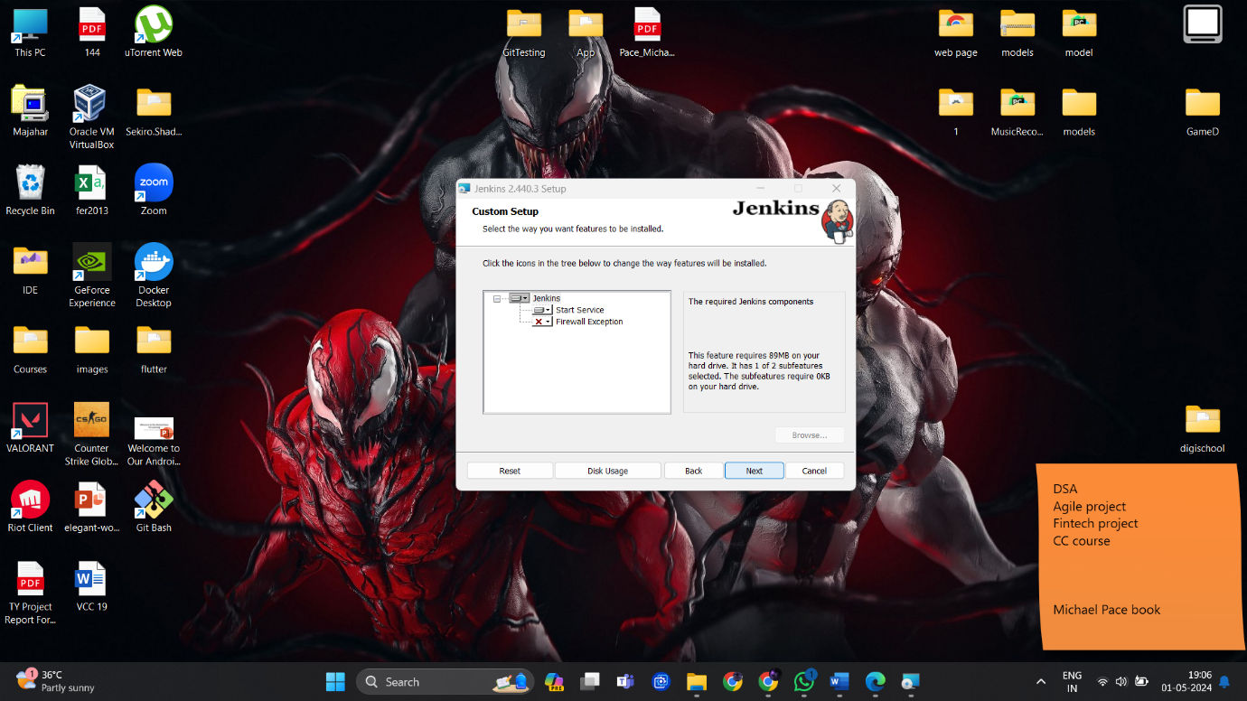

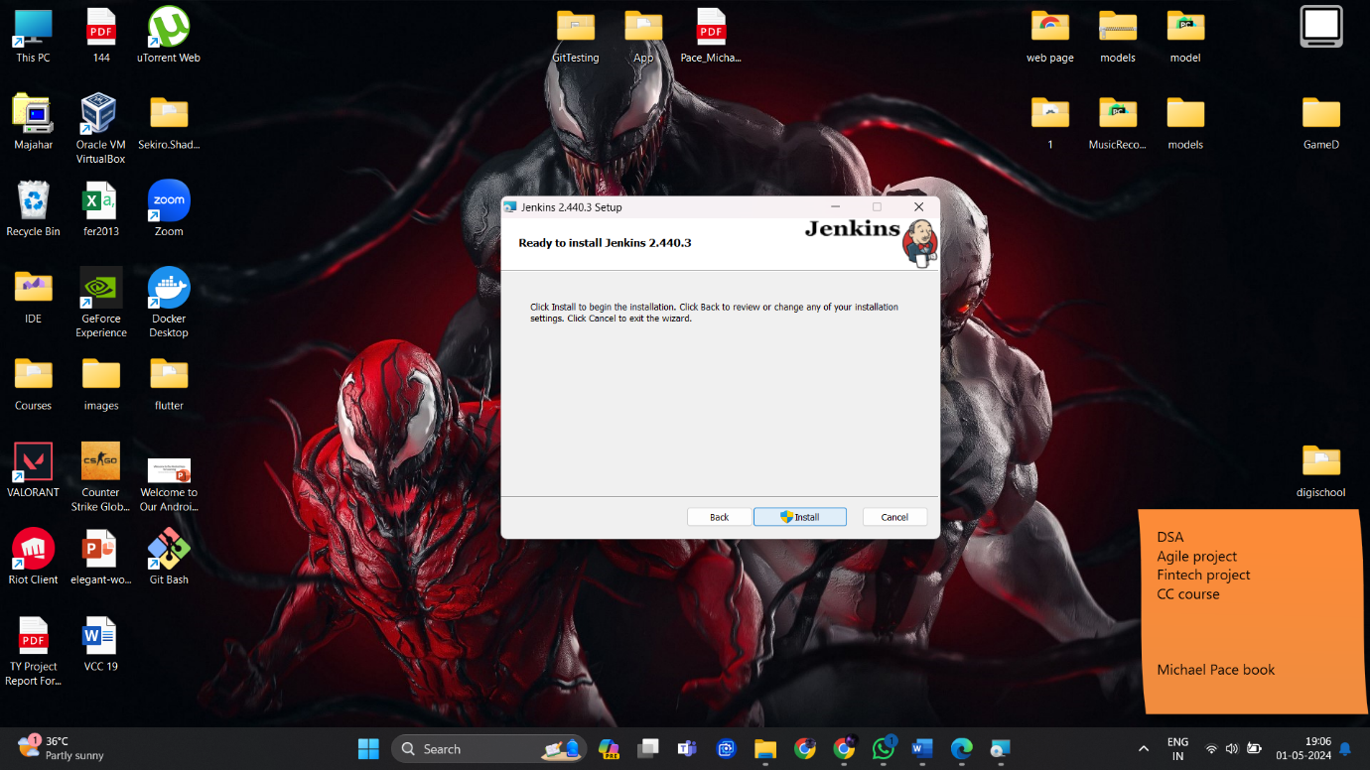

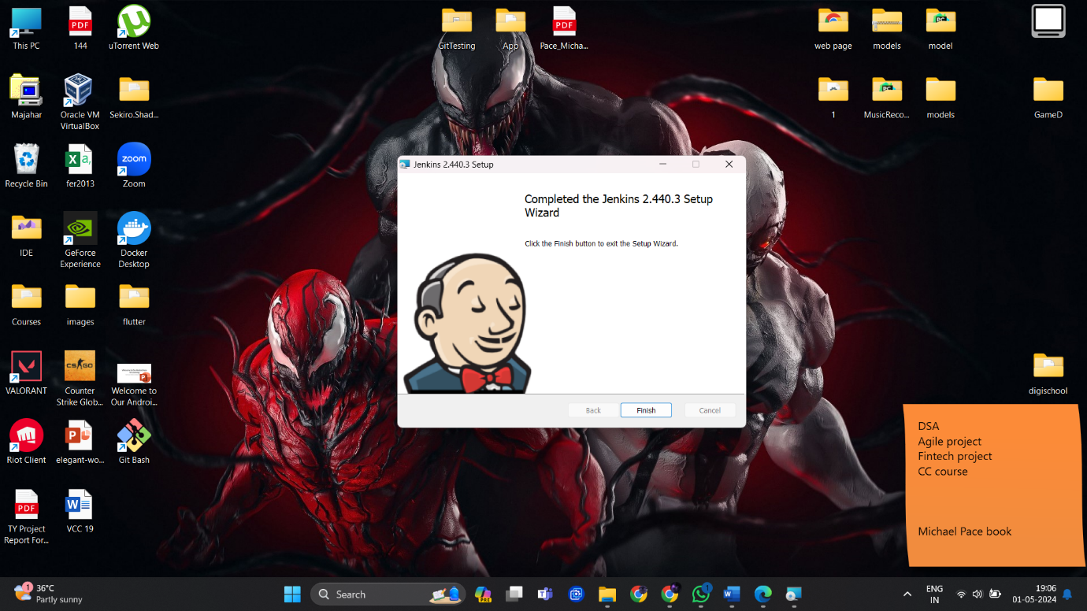

Now Jenkins is installed in our local machine, Let’s unlock it now.

1. Go to localhost:8080 as per the Jenkins official website asked to unlock Jenkins.

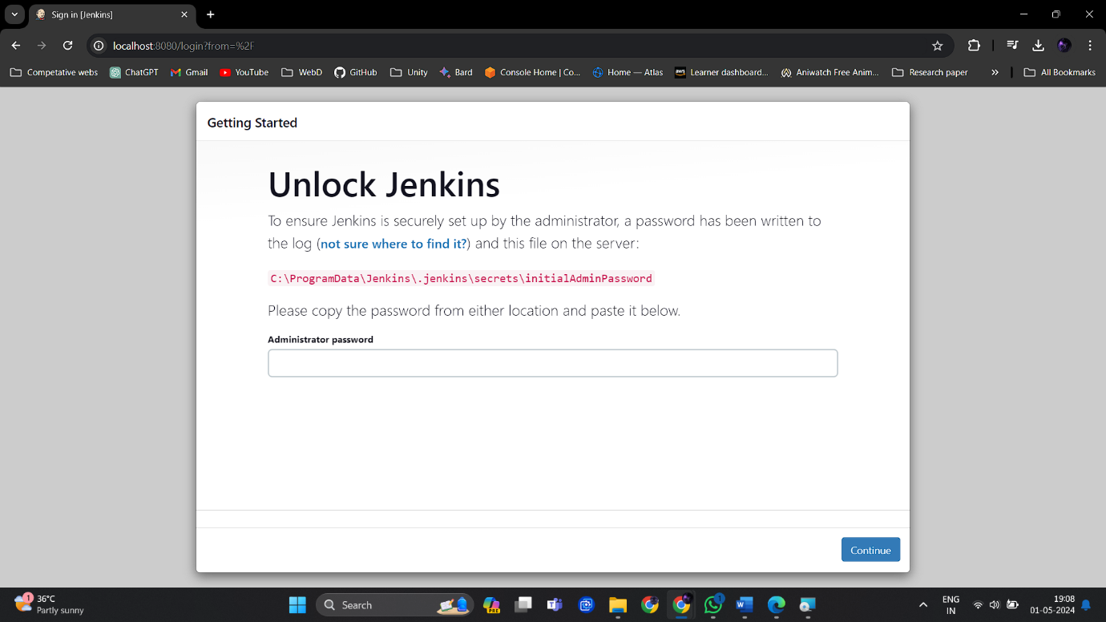

Getting the above webpage means Jenkins is successfully installed.

1. Enter the key that is at the provided location in the local machine.

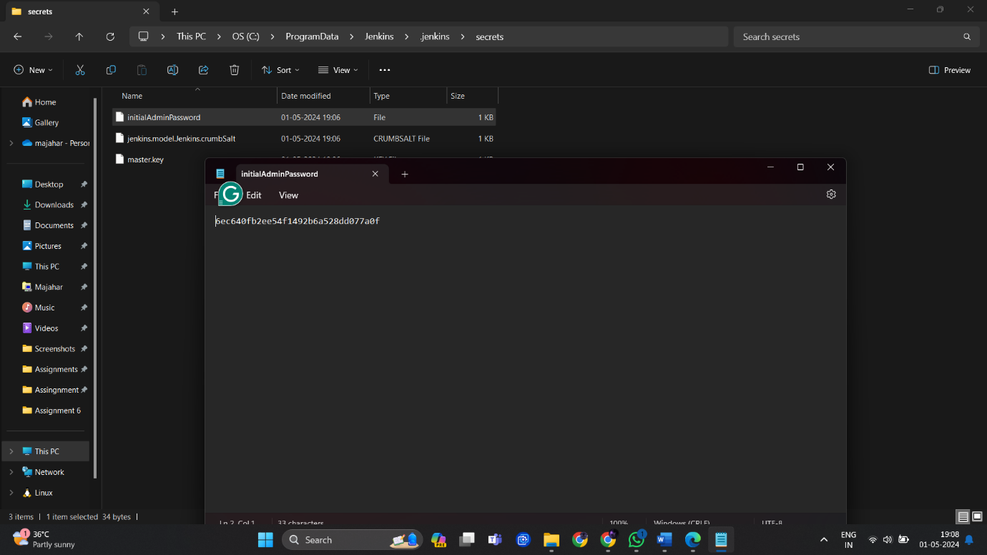

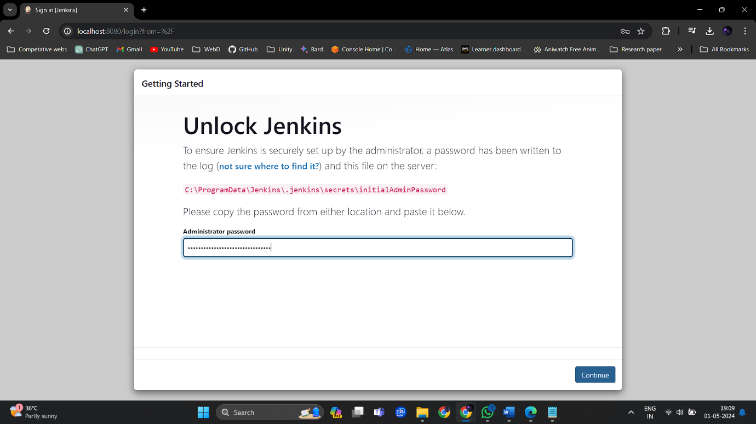

1. Choose suggested plugins for installation.

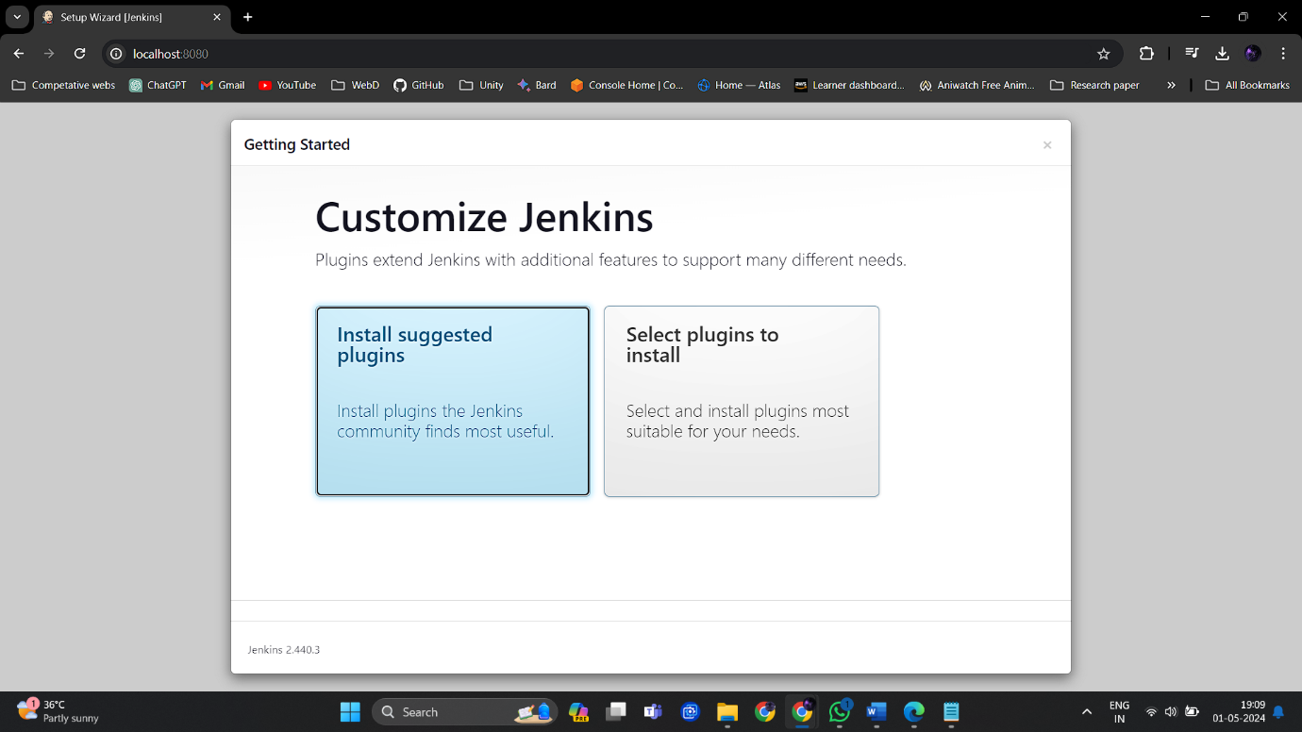

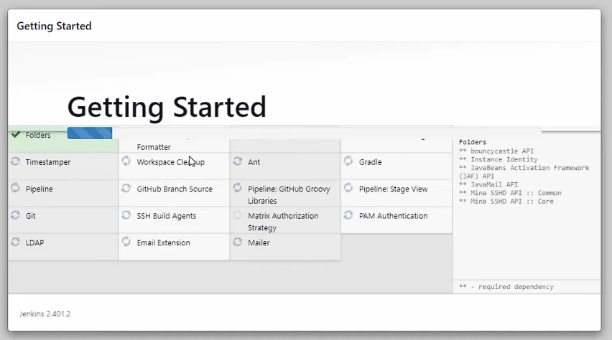

1. When the plugins are installed, create user admin.

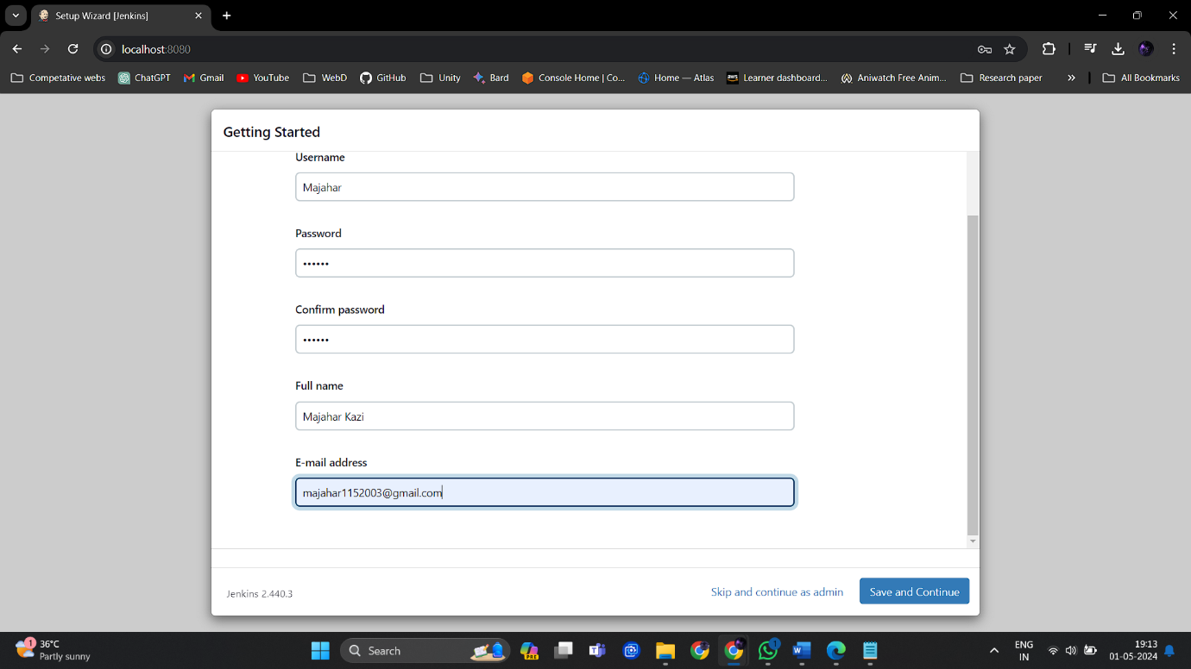

1. Instance configuration.

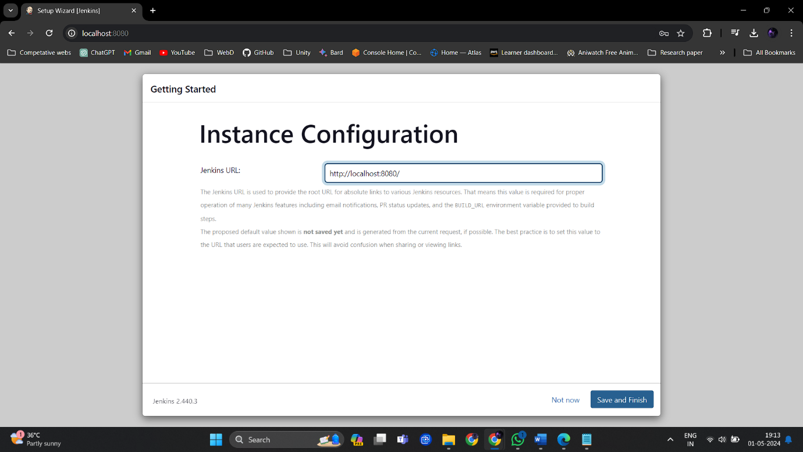

1. Launch Jenkins.

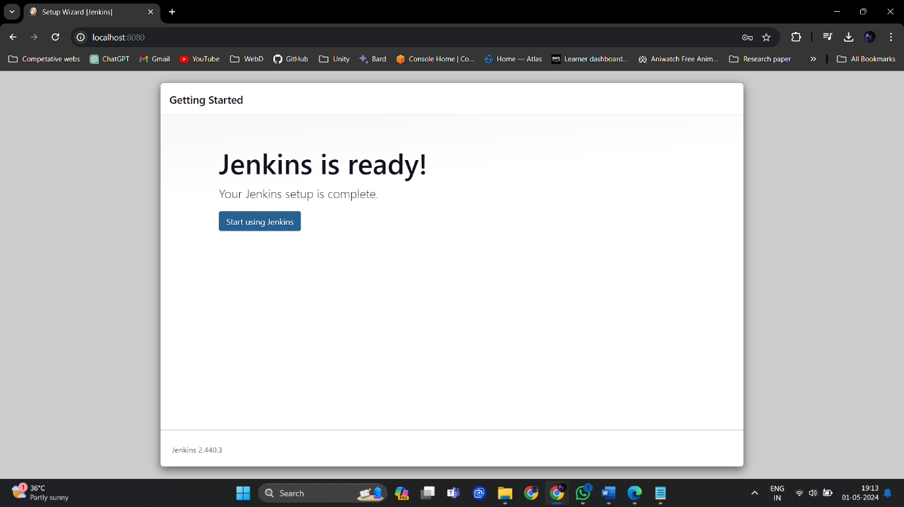

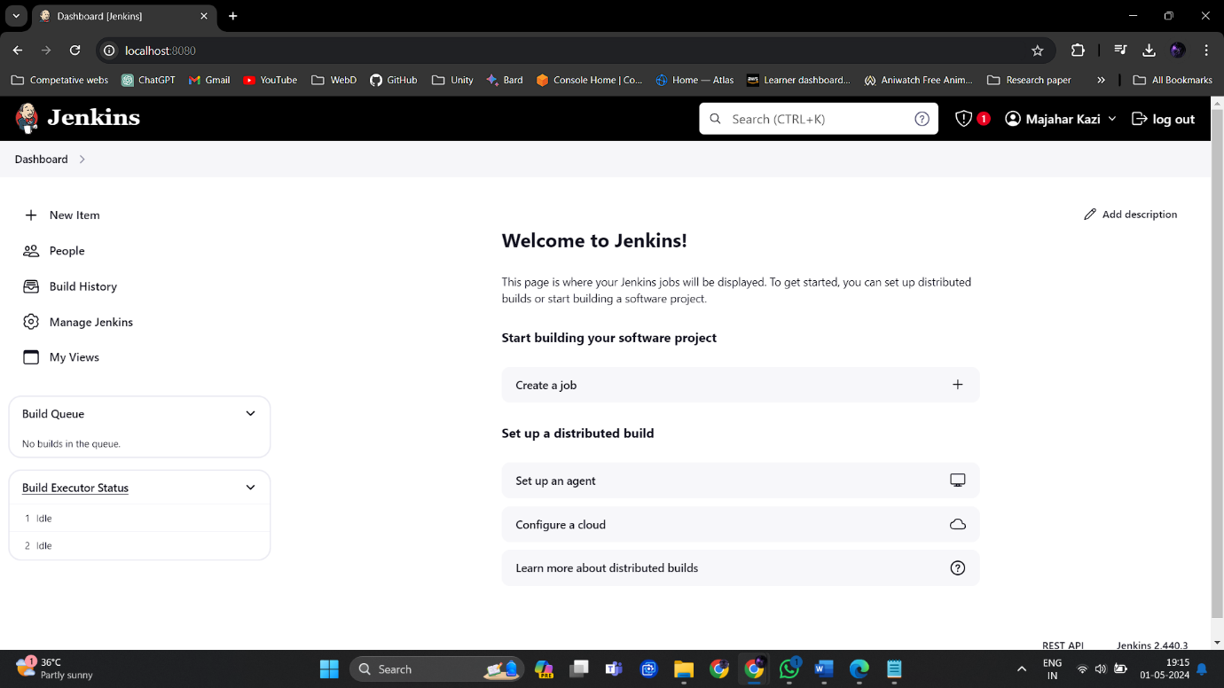

1. We can also logout and login with our admin credentials.

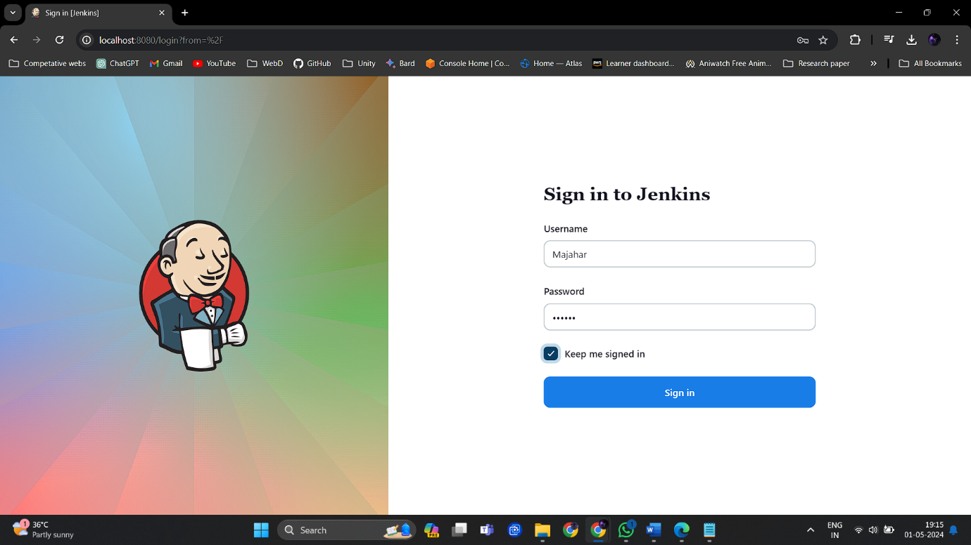

**Conclusion:**

Installing Jenkins and completing the post-installation setup wizard are crucial initial steps in establishing a robust CI/CD infrastructure. By unlocking Jenkins, administrators gain access to a powerful automation platform that streamlines software development workflows, improves productivity, and enhances collaboration among development teams. With Jenkins configured and accessible, organizations can accelerate their software delivery pipelines, reduce manual intervention, and achieve greater efficiency in delivering high-quality software products.